Name: ____________ Class: ____ Number: ____ Date: __/___
FILL IN THE BLANKS
- _______ was in the _______. He ___ _______ __________. He was ___________.
- _____ and ______ were in the _______. They _____ _________. They ____ ______.
- ________ ____ at the ______. He ____ ______ ______. It ____ ________.
PICTURE STORIES
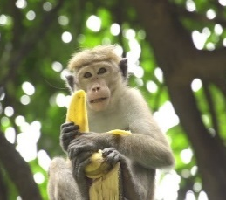 | It was in the forest.  It was eating a banana.  It was delicious. | 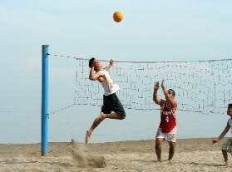 | They were at the beach.  They were playing volleyball.  They were happy.

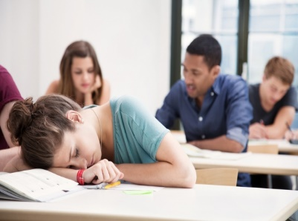
____________________________________________________
____________________________________________________
____________________________________________________

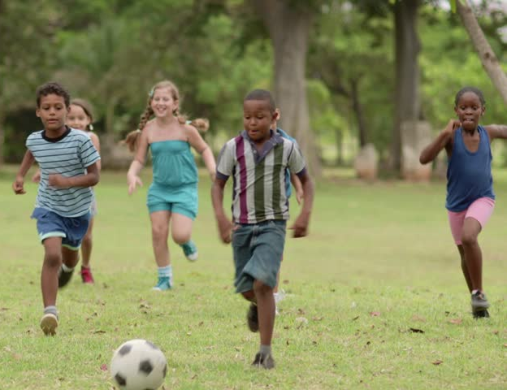
____________________________________________________
____________________________________________________
____________________________________________________

____________________________________________________
____________________________________________________
____________________________________________________

____________________________________________________
____________________________________________________
____________________________________________________
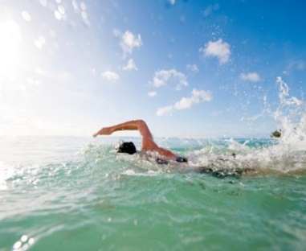
____________________________________________________
____________________________________________________
____________________________________________________
____________________________________________________
____________________________________________________
____________________________________________________

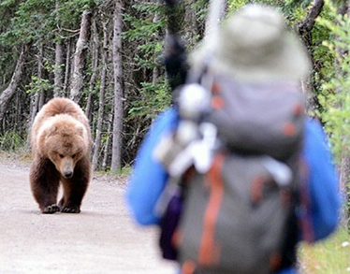
____________________________________________________
____________________________________________________
____________________________________________________

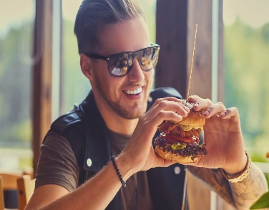
____________________________________________________
____________________________________________________
____________________________________________________

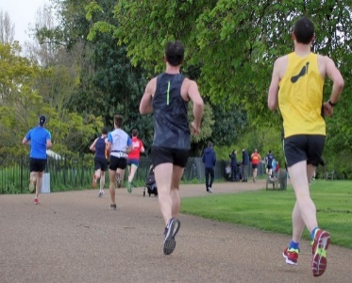
____________________________________________________
____________________________________________________
____________________________________________________
ABOUT YOU

____________________________________________________
____________________________________________________
____________________________________________________

