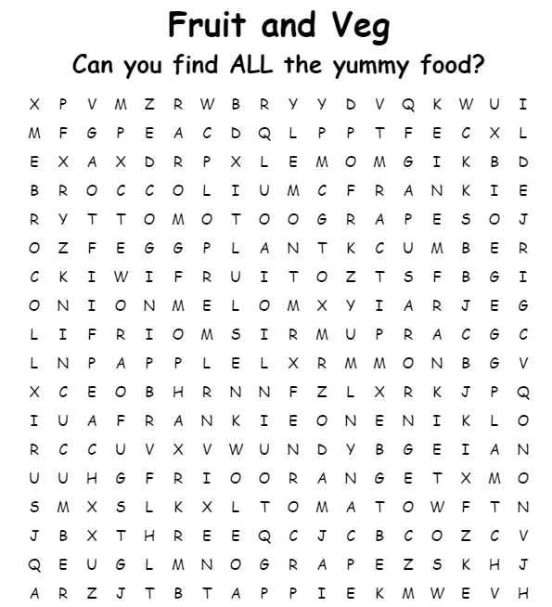
apple | APPLE
lemon | |||||||||||||||||
melon | |||||||||||||||||
tomato | |||||||||||||||||
onion | |||||||||||||||||
orange | |||||||||||||||||
cucumber | |||||||||||||||||
eggplant | |||||||||||||||||
broccoli | |||||||||||||||||
peach | |||||||||||||||||
grapes | |||||||||||||||||
kiwi fruit | |||||||||||||||||

 | 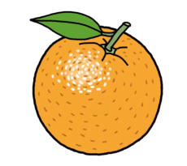 | 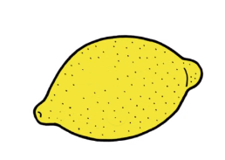
apple | orange | lemon | cucumber
APPLE | ORANGE | LEMON | CUCUMBER
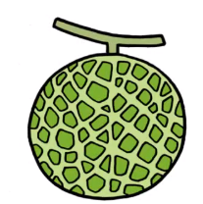
 |  | 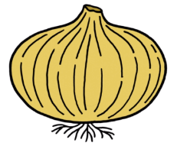
tomato | eggplant | onion | melon
TOMATO | EGGPLANT | ONION | MELON
 |  |  | 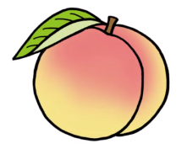
kiwi fruit | broccoli | grapes | peach
KIWI FRUIT | BROCCOLI | GRAPES | PEACH

