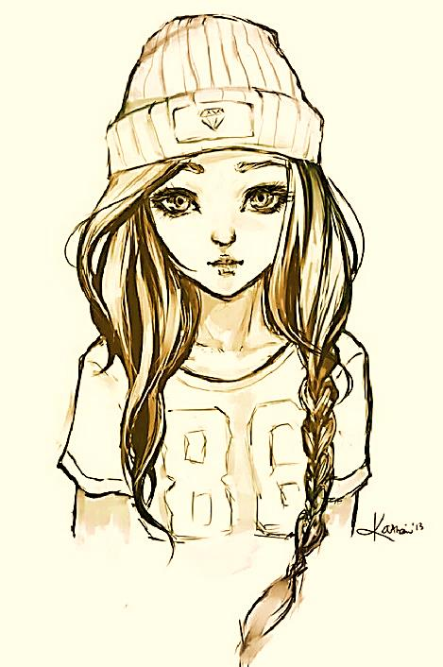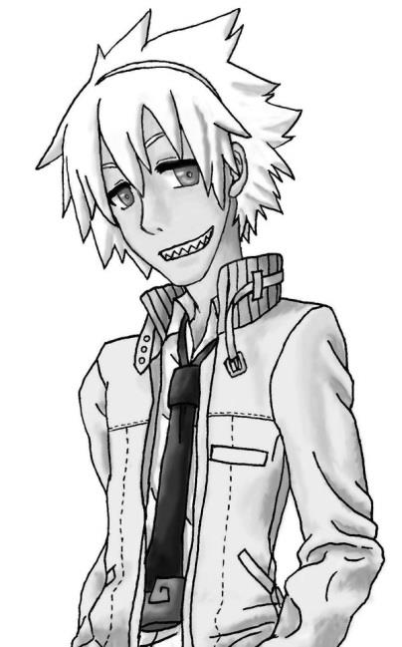

Yes, she does. (1 point) No, she doesn’t. (0 points)

My Buddy

**Round Two**

Total: _______

Name: _________

Points: ________

Name: _________

Points: ________

Name: _________

Points: ________

1. Does she read (manga) (magazines)?
2. Does she play (volleyball) (basketball)?
3. Does she eat (apples) (grapes)?
4. Does she speak (English) (French)?

**Round One**

Total: _______

Name: _________

Points: ________

Name: _________

Points: ________

Name: _________

Points: ________

Yes, he does. (1 point) No, he doesn’t. (0 points)

1. Does he play (soccer) (baseball)?
2. Does he eat (rice) (bread) for breakfast?
3. Does he like (movies) (music)?
4. Does he use a (smartphone) (computer)?

Name: _______________