Name: _________________ Class: ______ Number: ____ Date: ____/____
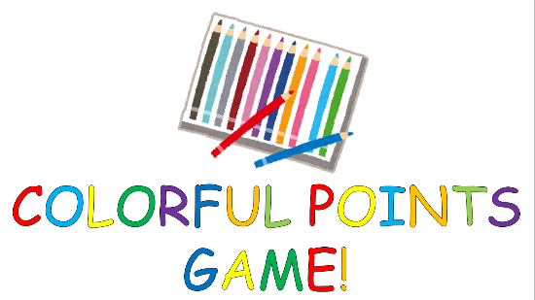
Friends are something to see at school.
I’m going to the park to play soccer.

- What is something to drink in the summer?
_______________________________________________________
_______________________________________________________
- What do people go to Australia to see?
_______________________________________________________
_______________________________________________________
- What is something to eat in Italy?
_______________________________________________________
_______________________________________________________
- Where do you want to go? What do you want to do?
_______________________________________________________
_______________________________________________________
- What are something to see in the spring?
_______________________________________________________
_______________________________________________________
- What do people go to Tokyo to do?
_______________________________________________________
_______________________________________________________
- What is something to say at school?
_______________________________________________________
_______________________________________________________
- Where will you go this weekend? What will you do?
_______________________________________________________
_______________________________________________________
- What are something to use in English class?
_______________________________________________________
_______________________________________________________
- What do people go to 7eleven to buy?
_______________________________________________________
_______________________________________________________
- What are something to see in South Africa?
_______________________________________________________
_______________________________________________________
- What do people come to Uonuma to do?
_______________________________________________________
_______________________________________________________
- What is something to hear on the radio?
_______________________________________________________
_______________________________________________________

