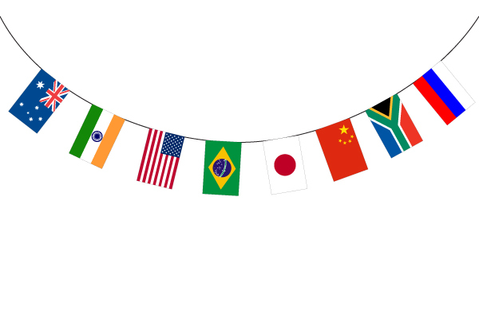
Which should she choose?

In October, Naomi Osaka will have to choose to be a Japanese or American citizen. Which should she choose?

She should become a [ Japanese / American ] citizen.
___________________________________________________________________
___________________________________________________________________

Name | Which should she choose? | Why?

