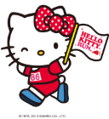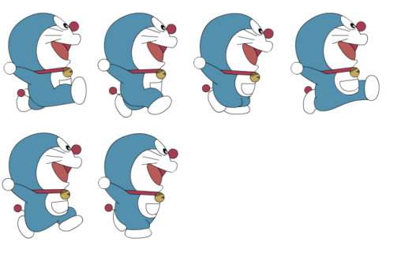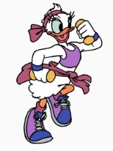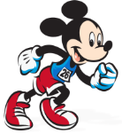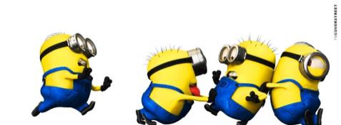***FIND THE MISTAKES / FIX THE DIALOGUES***

**Name: _________________**

**1.**

What special food is ate in Uonuma?

____________________________________________

_______ is maked here.

____________________________________________

**2.**

What wild animals is seen here?

____________________________________________

_______ are saw in the mountains.

____________________________________________

**3.**

What sports are enjoyed the most on winter?

____________________________________________

___ and ___ enjoyed the most.

____________________________________________

**4**.

What is spoked before and after eating?

____________________________________________

Before dinner ____ and after _____ is spoked.

____________________________________________

**5.**

What songs are sung for you in Karaoke boxes?

____________________________________________

_____ is sung on me. I love that song.

____________________________________________

**6.**

Is shoes worn in your house?

____________________________________________

No, they aren’t. They are took off at the door.

____________________________________________