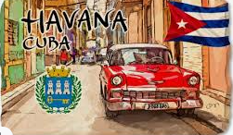
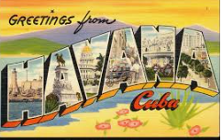
Name:___ ____________________________________class:________Date:______________
My bucket list

I want to zip line
I want to visit Cuba

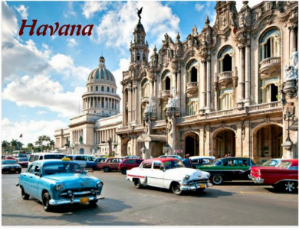
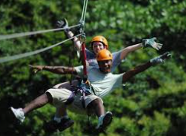
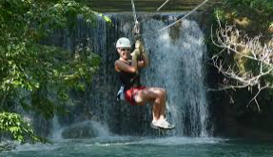

I want to buy a rabbit

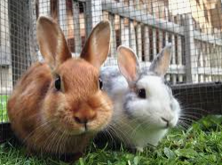
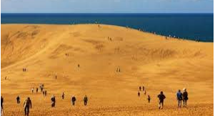

I want to visit Tottori

I have visited an onsen. I have climbed a mountain.
I have ridden an ATV. I have seen the Grand Canyon.
I have visited Enoshima Island. I have visited a Japanese shrine.

Activity 1. Write 6 things you have done and 2 or 3 things you want to do.

1. 4.

2. 5.

3. 6.

__________________________________
____________________________________________________________________
__________________________________

