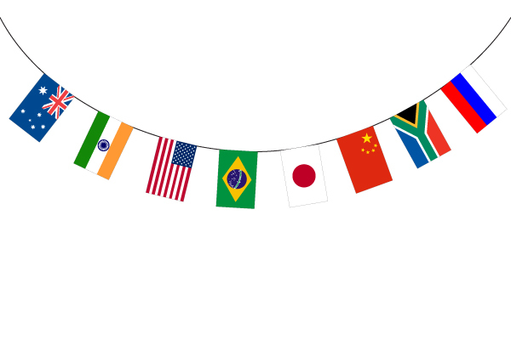
Citizenship

In October, Naomi Osaka will have to choose to be a Japanese or American citizen. What are the advantages of each?

American Citizenship | Japanese Citizenship

Which do you think she should choose?

Should Japan allow dual citizenship?

