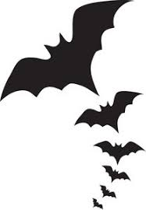
1. How many Americans celebrate Halloween? (ハロウィーンをお祝いするアメリカ人は何パーセントですか。)
☐A. 30% ☐B. 55% ☐C. 70% ☐D. 100%
2. How many Americans will buy candy for Halloween? (ハロウィーンキャンディーを買うアメリカ人は何パーセントですか。)
☐A. 95% ☐B. 100% ☐C. 75% ☐D. 30%
3. How much will Americans spend on Halloween candy? (ハロウィーンキャンディーのためにどれくらいお金を使いますか。)
☐A. 1,005,000 dollars ☐B. 5,000,000 dollars
☐C. 10,000,000,000 dollars ☐D. 3,000,000,000 dollars
4. When do Americans buy Halloween decorations? (アメリカ人はハロウィーンの飾りをいつ買いますか。)
☐A. October ☐B. September ☐C. August ☐D. July
5. How many pumpkins will Americans buy? (アメリカ人はカボチャをいくつ買いますか。)
☐A. 2,000,000 pumpkins ☐B. 500,000,000 pumpkins
☐C. 100,000 pumpkins ☐D. 150,000,000 pumpkins
6. What is the most popular costume for dogs? (犬の仮装で最も人気なものは何ですか。)
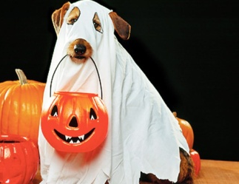
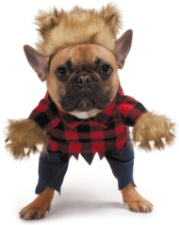
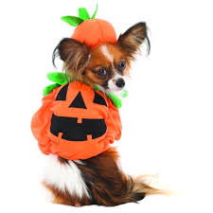
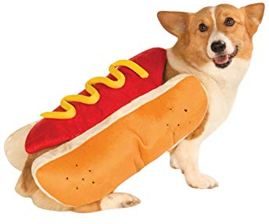

☐A. pumpkin ☐B. hot dog ☐C. werewolf ☐D. ghost
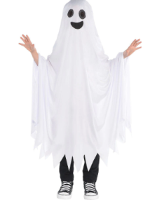
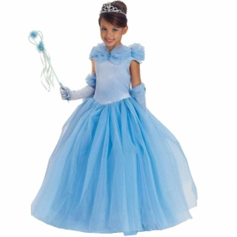
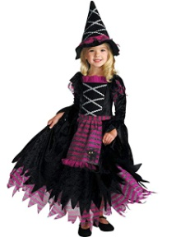
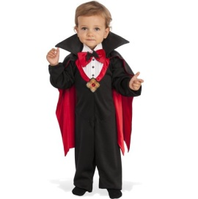
7. What is the most popular costume for children? (子どもの仮装で最も人気なものは何ですか。)

☐A. ghost ☐B. princess ☐C. witch ☐D. Dracula
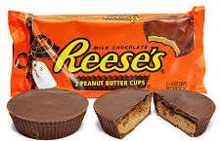
8. What is the most popular Halloween candy? (一番人気のハロウィーンキャンディーは何ですか。)
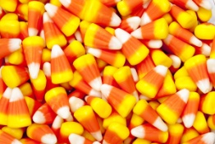
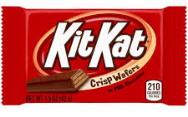
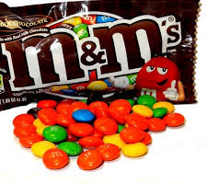

☐A. candy corn ☐B. Kit Kat ☐C. Reese’s peanut butter cups ☐D. M&M’s
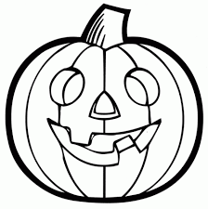
1. How many Americans celebrate Halloween?
☐A. 30% ☐B. 55% ☐C. 70% ☐D. 100%
2. How many Americans will buy candy for Halloween?
☐A. 95% ☐B. 100% ☐C. 75% ☐D. 30%
3. How much will Americans spend on Halloween candy?
☐A. 1,005,000 dollars ☐B. 5,000,000 dollars
☐C. 10,000,000,000 dollars ☐D. 3,000,000,000 dollars
4. When do Americans buy Halloween decorations?
☐A. October ☐B. September ☐C. August ☐D. July
5. How many pumpkins will Americans buy?
☐A. 2,000,000 pumpkins ☐B. 500,000,000 pumpkins
☐C. 100,000 pumpkins ☐D. 150,000,000 pumpkins
6. What is the most popular costume for dogs?

☐A. pumpkin ☐B. hot dog ☐C. werewolf ☐D. ghost
7. What is the most popular costume for children?

☐A. ghost ☐B. princess ☐C. witch ☐D. Dracula
8. What is the most popular Halloween candy?

☐A. candy corn ☐B. Kit Kat ☐C. Reese’s peanut butter cups ☐D. M&M’s
1. How many Americans celebrate Halloween? (ハロウィーンをお祝いするアメリカ人は何パーセントですか。)
☐A. 30% ☐B. 55% ■C. 70% ☐D. 100%
2. How many Americans will buy candy for Halloween? (ハロウィーンキャンディーを買うアメリカ人は何パーセントですか。)
■A. 95% ☐B. 100% ☐C. 75% ☐D. 30%
3. How much will Americans spend on Halloween candy? (ハロウィーンキャンディーのためにどれくらいお金を使いますか。)
☐A. 1,005,000 dollars ☐B. 5,000,000 dollars
☐C. 10,000,000,000 dollars ■D. 3,000,000,000 dollars
4. When do Americans buy Halloween decorations? (アメリカ人はハロウィーンの飾りをいつ買いますか。)
☐A. October ■B. September ☐C. August ☐D. July
5. How many pumpkins will Americans buy? (アメリカ人はカボチャをいくつ買いますか。)
☐A. 2,000,000 pumpkins ☐B. 500,000,000 pumpkins
☐C. 100,000 pumpkins ■D. 150,000,000 pumpkins
6. What is the most popular costume for dogs? (犬の仮装で最も人気なものは何ですか。)

■A. pumpkin ☐B. hot dog ☐C. werewolf ☐D. ghost
7. What is the most popular costume for children? (子どもの仮装で最も人気なものは何ですか。)

☐A. ghost ☐B. princess ■C. witch ☐D. Dracula
8. What is the most popular Halloween candy? (一番人気のハロウィーンキャンディーは何ですか。)

☐A. candy corn ☐B. Kit Kat ■C. Reese’s peanut butter cups ☐D. M&M’s

