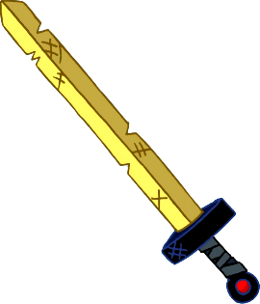
Word battle!✰
Today’s warming up, let’s test your English knowledge. How many words can you remember?
- DO NOT WORRY ABOUT SPELLING!
- WRITE IN ENGLISH ONLY!
- HAVE FUN!
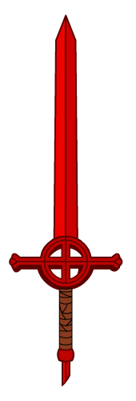
★
(30 seconds) Round 1: ________________
Score:_________
★ The winner of round 1 is: ___________________________

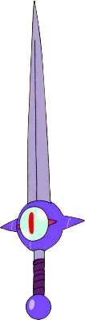
★★
(45 seconds) Round 2: ________________
Score:_________
★ The winner of round 2 is: ___________________________

★★★
(1 minute) Round 3: ________________
Score:_________
★ The winner of round 3 is: ___________________________
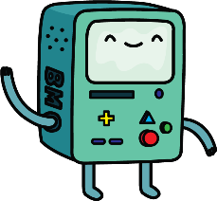

Name ( ) Class ( ) No ( )
Warming up ①
Word battle!
Today’s warming up, let’s test your English knowledge. How many words can you remember?
- DO NOT WORRY ABOUT SPELLING!
- WRITE IN ENGLISH ONLY!
- HAVE FUN!

(30 seconds) Round 1: colors
red, orange, yellow, green, blue, indigo, violet, brown, purple, black, white, grey, light blue, dark blue, light green, dark green, pink, silver, gold, bronze etc..
Score:_________
★ The winner of round 1 is: _______________________________

(45 seconds) Round 2: sports
baseball, basketball, soccer, handball, dodgeball, tennis, table tennis, swimming, karate, judo, kabaddi, cricket, volleyball, running, gymnastics, skating, badminton, etc..
Score:_________
★ The winner of round 2 is: _______________________________

(1 minute) Round 3: v verbs 動詞
play, do, sleep, study, watch, go, fly, use, win, lose, hit, become, hurt, put, read, write, bring, build, catch, buy, have, feel, say, meet, spend, stand, hold, hear, fight, see, shake, teach, think, understand, swim, take, wear, eat, drink, drive, draw, tell, begin, know, sing, show, leave, keep…
Score:_________
★ The winner of round 3 is: _______________________________

Name ( ) Class ( ) No ( )

