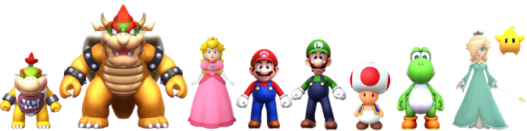
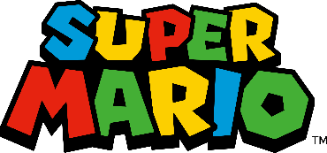

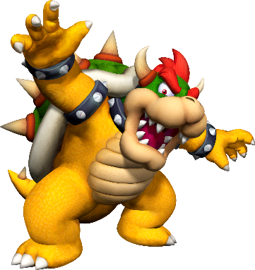
Do you call Koopa _________?
あなたはクッパを「英語の名前」と呼びますか？
- Shroomy
- Bowser
- Dragon
- King Krool

Level 1:
- Cheep Cheep ________________
- ________________ ________________
- ________________ ________________
- ________________ ________________
Level 2:
- ________________ ________________
- ________________ ________________
- ________________ ________________
- ________________ ________________
Level 3:
- ________________ ________________
- ________________ ________________
- ________________ ________________
- ________________ ________________

