Name:______________________________ Class___________

Deserted Island (part 1)

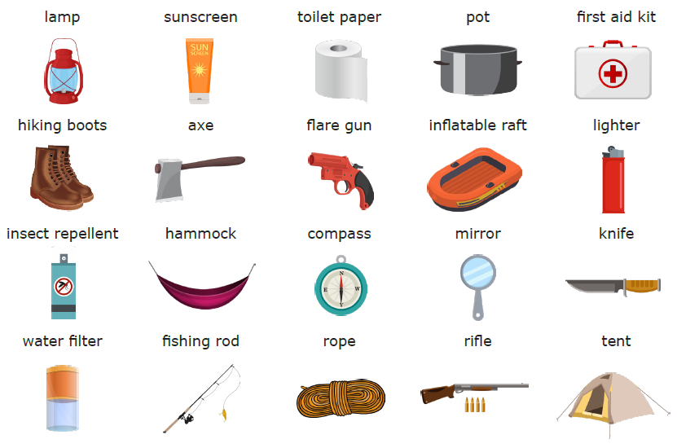
Your boat hit a rock! You are sinking! You see an island nearby. Choose 3 items to bring with you to the mystery island!

- We will bring a ___________________________ because ____________________________________________

_____________________________________________________________________________________________

- We will bring a ___________________________ because ____________________________________________

_____________________________________________________________________________________________

- We will bring a ___________________________ because ____________________________________________

_____________________________________________________________________________________________

Name:______________________________ Class___________
Deserted Island (part 2)
You arrive on the mystery island. You explore it and find out it is not a normal island. You must survive on this island for 10 days. How will you use your 3 items to survive?

- We will use a ___________________ to ___________________________________________________________

- We will use a ___________________ to ___________________________________________________________

- We will use a ___________________ to ___________________________________________________________

Will you survive?

We will thrive. We will survive. We will die.

