Name: Date:

Guess who

How to play: Pick one character, Play rock, paper scissors. WINNER can ask 3 times LOSER can ask

Get many character names!

*Ask: Are you tall? Are you from____? Are you young? Are you a boy/girl? Where are you from?

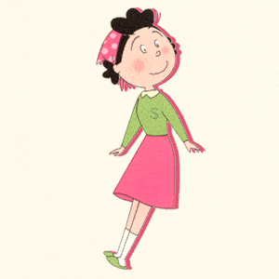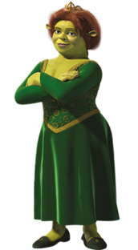 

From: Japan 

Age: 24

Height: 159

Name: Sazae San

From: England 

Age: 7

Height: 140cm

Name: Alice

From: England 

Age: 65

Height: 200cm

Name: Thomas the train

From: America 

Age: 2

Height: 188

Name: Baymax

From: The sea 

Age: 12

Height: 15cm

Name: Sebastian

From: The sea 

Age: 34

Height: 10cm

Name: Sandy Cheeks

From: Japan 

Age: 15

Height: 162

Name: Hinata Shoyo

From: Japan 

Age: 11

Height: 129cm

Name: Doraemon

From: America 

Age: 35

Height: 178cm

Name: Princess Fiona