Eiken Writing Practice

Name:

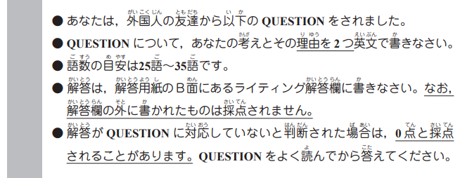

Example: Do you like going to festivals in the summer?

( Answer ) ( Reason 1 )
No, I don’t. First, it’s too hot in the summer, so I don’t want
( Reason 2 )
to go to festivals. Second, festivals are often very crowded. I

don’t like going to crowded places.

1. Which do you like better, riding a bike or taking the train?
_____________________________________________________________________________________________________________________________________________________________________________________________________________________________________________________

2. Where do you want to go on vacation?
_____________________________________________________________________________________________________________________________________________________________________________________________________________________________________________________

3. What do you want to be in the future?
_____________________________________________________________________________________________________________________________________________________________________________________________________________________________________________________

