A: Did you _______? A: Did you _______?
B: No, I didn’t. B: Yes, I did.
Did you __________ yesterday?
Circle Y or N then write the person’s name on the line below.
Did you travel during winter vacation?  Y / N  ________________  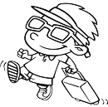 | Did you use Doraemon’s take-copter?  Y / N  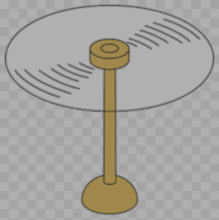  ________________ | Did you watch TV yesterday?  Y / N  ________________ | Did you eat takoyaki yesterday?  Y / N  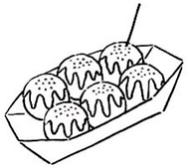  ________________
Did you clean your room last Saturday?  Y / N  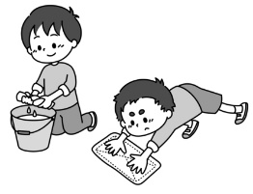  ________________ | Did you listen to music last night?  Y / N  ________________ | Did you do your homework?  Y / N  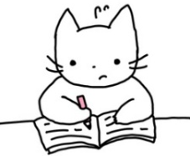  ________________ | Did you go to Tokyo last week?  Y / N  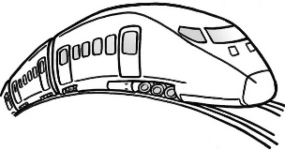  ________________
Did you make a cake yesterday?  Y / N  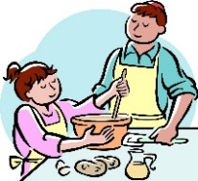  ________________ | Did you play video games last night?  Y / N  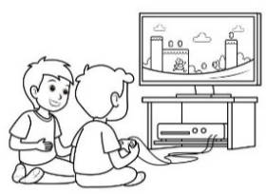  ________________ | Did you have breakfast this morning?  Y / N  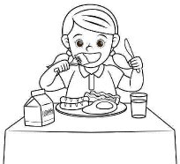  ________________ | Did you study English yesterday?  Y / N  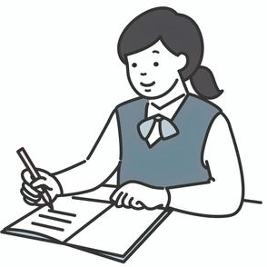  ________________
Did you read a book yesterday?  Y / N  ________________ | Did you come to school by bike?  Y / N  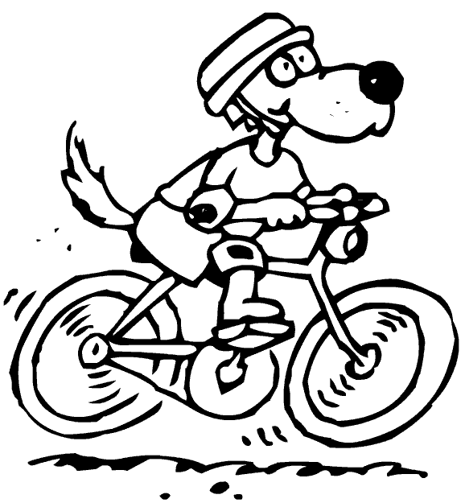  ________________ | Did you see a UFO yesterday?  Y / N  ________________ | Did you leave school early yesterday?  Y / N  ________________

Present - Past
travel - traveled | play - played | make – made | read – read
use – used | listen – listened | go – went | come – came
watch – watched | study – studied | have – had | leave – left
clean - cleaned | do – did | see - saw | eat – ate

Please use the information on the previous page to write sentences on the lines provided.
Example 1: Yes
Amy made a cake yesterday.
Example 2: No
Tom didn’t read a book yesterday.

1. ______________________________________________________________________
2. ______________________________________________________________________
3. ______________________________________________________________________
4. ______________________________________________________________________
5. ______________________________________________________________________
6. ______________________________________________________________________
7. ______________________________________________________________________
8. ______________________________________________________________________
9. ______________________________________________________________________
10. _____________________________________________________________________

