Please help me!
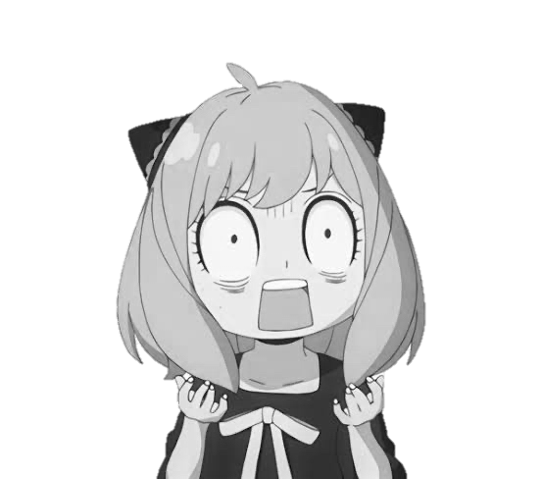

1 | 2 | 3 | 4 | 5 | 6 | 7 | 8 | 9 | 10
L | G | T | N | C | F | P | B | E | Y
11 | 12 | 13 | 14 | 15 | 16 | 17 | 18 | 19 | 20
A | S | H | Q | D | R | K | U | W | O

Secret message:

_______________________________________________________________________________________

L | O | O | K
1 | 20 | 20 | 17
Please help me!
U | N | D | E | R
18 | 4 | 15 | 9 | 16
T | H | E
3 | 13 | 9

T | A | B | L | E
3 | 11 | 8 | 1 | 9

1 | 2 | 3 | 4 | 5 | 6 | 7 | 8 | 9 | 10
L | G | T | N | C | F | P | B | E | Y
11 | 12 | 13 | 14 | 15 | 16 | 17 | 18 | 19 | 20
A | S | H | Q | D | R | K | U | W | O

Secret message:
Look under the table. (テーブルの下を見て。)

