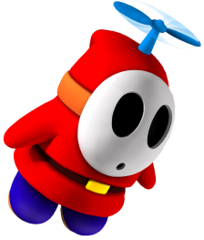
How long have you…

studied _______? liked ________?
played ________? spoken ________?
lived in _______? known _________?
had _________? wanted ________?
been _________? made __________?

vs teachers!

I don’t __________.
For a long time.
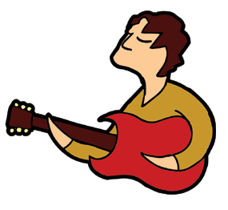
I don’t __________.
For a long time.

I don’t __________.
For a long time.

