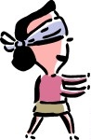
That looks like…

Please draw a picture. Don’t look!

What do your friends think?

- That looks like _________________________________________
- ______________________________________________________
- ______________________________________________________
- ______________________________________________________
- ______________________________________________________
- ______________________________________________________
- ______________________________________________________
- ______________________________________________________

