Name: Class: Number:
New Crown 3 - Get1
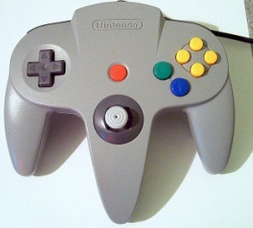
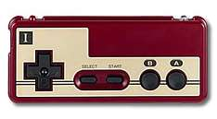
I have played Nintendo for about 28 years .
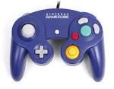

Step 1. Finish the sentences.

- I have liv in for years.
- I have stud English for years.
- I have been a 3rd year student for months.
- I have ridden a bicycle for years.
- I have had my shoes for .
- I have played for .

Step 2: Write 3 new TRUE sentences. Example: I have played Biohazard for 7 years.
Used a computer played games played Nintendo
played the piano eaten natto curry
studied English been an Arashi fan had a dog
been a volleyball player had my shoes

Step 3: Write 1 LIE (1つのうそをつく) example: I have had a Ferrari for 10 years.

Name
うそはどちら：

1.
<ALT>
A B C D
2.

A B C D
3.

A B C D
4.

A B C D
5.

A B C D
6.

A B C D
7.

A B C D
8.

A B C D
9.

A B C D
10.

A B C D
11.

A B C D

BRIEF OUTLINE: Students practice writing sentences using the present perfect. Then they write 3 true statements and 1 false statement about their lives. Other students must guess which is the false statement.

DETAILED EXPLANATION:
- Hand out worksheets and go over the grammar. I recommend presenting your own answers to the given questions and having the students repeat your answers for pronunciation practice.
- Students try to complete step one ***Don't forget to write the name of your schools city in number 1***
- Practice reading the clauses in the box for step 2.
- Instruct the students to write 3 true sentences about themselves using those clauses for a guide, but allowing students to write anything else they can come up with if they so choose.
- Students write one lie.
- Do a demonstration with a volunteer, having all students write the volunteers name in the blank. The volunteer reads his/her 4 sentences and the rest of the class tries to guess the lie.
- Release students to try to guess classmates lies.

- During the demonstration, you'll have to announce the letter designations. I recommend writing huge letters: A B C D on the board. Call out "A!" and motion for the student to recite their first sentence. Then call out "B!" and motion for the next statement. And so on.

