Pronunciation Tree
berry

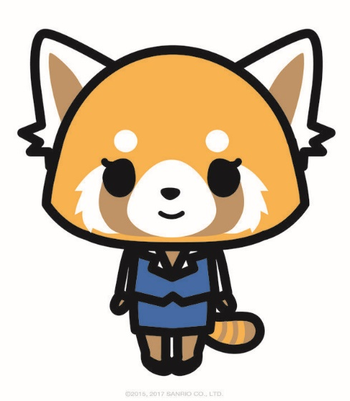
boat vote

curb curve curb curve

bury very bury very bury very bury very

best vest best vest best vest best vest
1 2 3 4 5 6 7 8

best vest best vest best vest best vest
17 18 19 20 21 22 23 24
very

vote boat

curve curb curve curb

very bury very bury very bury very bury

vest best vest best vest best vest best
9 10 11 12 13 14 15 16

vest best vest best vest best vest best
25 26 27 28 29 30 32 33
berry very
ban van
bat vat
beer veer
boat vote
bowl vole
serb serve
bars vase
best vest
bet vet
bowels vowels
gibbon given
bale veil
bent vent
bury very
bow vow
bane vein
bat vat
beer veer
bid vid
bile vile
biz viz
bolt volt
bowels vowels
bowl vole
broom vroom
curb curve
dribble drivel
dub dove
fibre fiver
jibe jive
lobes loaves
rebel revel
verb verve

