Name _____________________________ Class _____ Number _____
Which do you like, apples or oranges?
cats
cake
apples

oranges
dogs
ice-cream

.
First, your circle, then ask your partner and their circle.

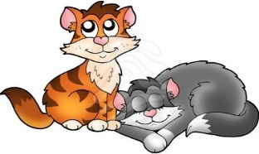
1. Which do you like, __________________ or ____________________
I like

My partner likes

2. Which do you want, __________________ or ____________________
I want

My partner wants

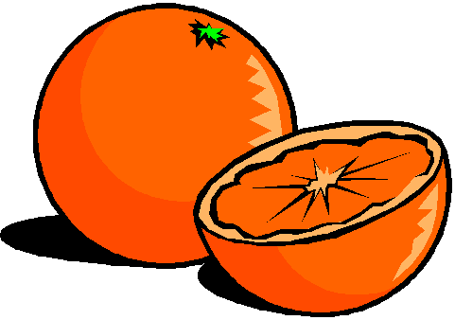
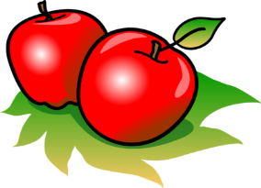
3. Which do you like, __________________ or ____________________
I like

My partner likes
Make an original sentence and draw the pictures.

4. Which do you like, __________________ or ____________________
I like

My partner likes

