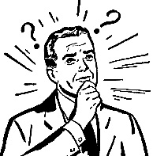
Odd One Out

Which is different? __________________

Why? ______________________________________________________

Which is different? __________________

Why? ______________________________________________________

Which is different? __________________

Why? ______________________________________________________

Which is different? __________________

Why? ______________________________________________________

Which is different? __________________

Why? ______________________________________________________

Which is different? __________________

Why? ______________________________________________________

