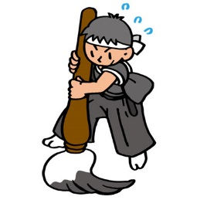
My Kanji
What was your kanji for this year?

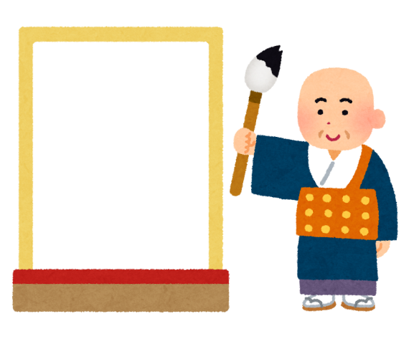 | Why?  __________________________  __________________________  __________________________  __________________________

Please ask your friends!

name | kanji | Why?

