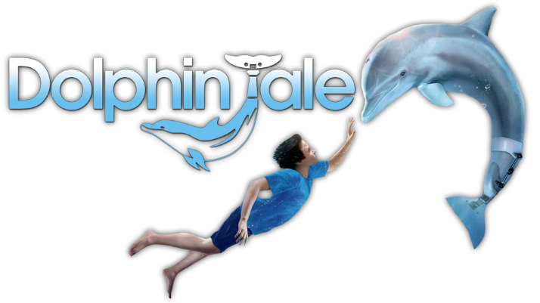
Name: __________________________________________________ Class: _________

NC3 Let’s Read 1 P.49

Questionnaire

- Where was the dolphin?
A | Climbing a mountain.
B | In the sea.
C | Lying on the beach.

- What was Sawyer doing when he found the dolphin?
A | Sawyer was on the bus.
B | He was at home.
C | He was riding his bike along the beach.

- Why did Sawyer have to take special summer classes?
A | Because he was smart.
B | He loved going there to study.
C | He was not doing well at school.

- Where did the ambulance take the dolphin to?
A | To Sawyer’s swimming pool.
B | To the animal hospital.
C | To the sea.
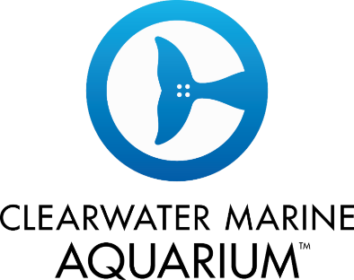
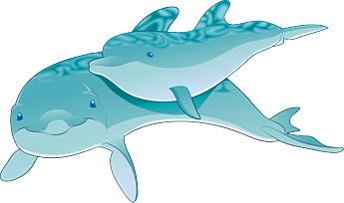
- What’s the name of the dolphin?
A | Winter.
B | Wiener.
C | Winner.

- Did Winter and Sawyer become good friends?
____ _ _____ ____ _

- What happened to Winter’s tail?
A | The doctor had to cut it off.
B | What tail? She was born without one (tail).
C | Nothing happened. Her tail was good.

- Why was Sawyer’s mom angry at him?
A | Sawyer was smelling like fish.
B | Because he was a lazy boy.
C | She was angry because he was not going to school.

- What did Winter do with the plastic tails made for her?
A | She broke them.
B | Winter didn’t like the color.
C | She gave them to another dolphin.

- How was the festival called?
A | Winter Matsuri.
B | Save Winter.
C | Save the earth.
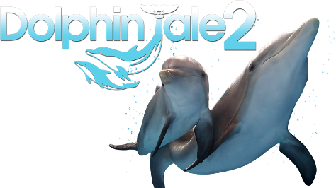

How many points did you get? __________

