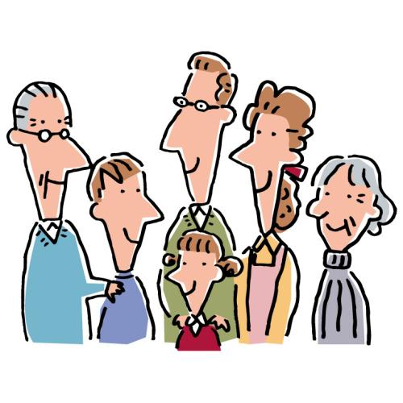
My family’s rules

Examples: (例)

We have to take our shoes off in the house.
We have to clean our rooms on Saturday.
We have to finish dinner before we can eat sweets.

ask permission | 許可を求める | say thank you | お礼を言う
tell our parents | 両親に教える | come home by ~ | ～までに家に帰る

Our rules:
- _________________________________
_________________________________
- _________________________________
_________________________________
- _________________________________
_________________________________
My family’s rules

Examples: (例)

We must take our shoes off in the house.
We have to clean our rooms on Saturday.
We must finish dinner before we can eat sweets.

ask permission | 許可を求める | say thank you | お礼を言う
tell our parents | 両親に教える | come home by ~ | ～までに家に帰る

Our rules:
- ___________________________________
___________________________________
- ___________________________________
___________________________________
- ___________________________________
___________________________________
- ___________________________________
___________________________________

