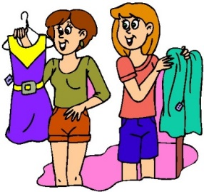Name _________________________ Class _____ Number _____

Why don't you come?

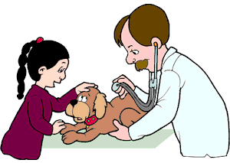1. Today is a holiday, and Sue wants to go to Ikebukuro to buy new clothes.

Example:

my

2. Kelly **has** to take her dog to the vet.

. Hello?

. Hello? This is Sue.May I speak to Kelly please?

. Sure. Just a second.

. Hi Sue. What’s up?

. Today is a holiday, and I want­_ to go to Ikebukuro

to buy new clothes. Why don’t you come?

. I’m sorry, but I can’t. I **have** to take my dog to the vet.

Fine. Maybe some other time.

Sue.



I

my

1. Tomorrow is a holiday, and wants to go to the park to have a picnic.

　　 2. Sam **has** to visit her grandmother in Gunma.

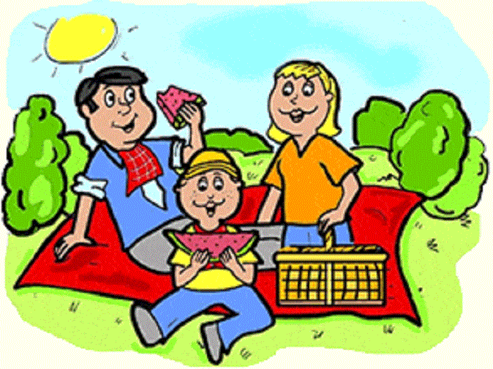

Kelly

A.

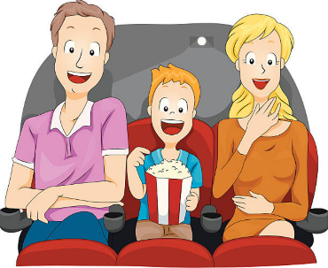

Jill

her

her

* Use A. or B. to make a new dialogue.

1. Today is Saturday, and Jill wants to go to the cinema to see a movie.

2. Becky **has** to finish homework.

. Hello?

. Hello? This is _______________. May I _______________________

_____________________________________________­­­___________

. Sure. Just a second.

. Hi __________________. What’s up?

. ____________________is_________________________________,

and I want to_____________________________________________

_____________________________________. Why don’t you come?

. I’m sorry, but I can’t.I __________ to_______________________________________________________

____________________________________________________________________

**.** Fine.___________________________________________________