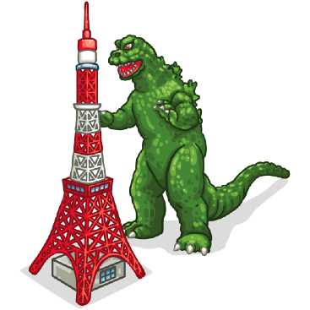
Pronunciation Tree
berry

van ban

bow vow bow vow

curb curve curb curve curb curve curb curve

bent vent bent vent bent vent bent vent
1 2 3 4 5 6 7 8

bent vent bent vent bent vent bent vent
17 18 19 20 21 22 23 24
very

van ban

vow bow vow bow

curve curb curve curb curve curb curve curb

vent bent vent bent vent bent vent bent
9 10 11 12 13 14 15 16

vent bent vent bent vent bent vent bent
25 26 27 28 29 30 32 33

