Step 1
EXAMPLES
at school 学校で
at my house 家で
on Sunday 日曜日に
every day 毎日
at 8 pm 午後八時に
- Where do you eat lunch?
  - I eat lunch _______________________.
- When do you read books?
  - I read books ______________________.
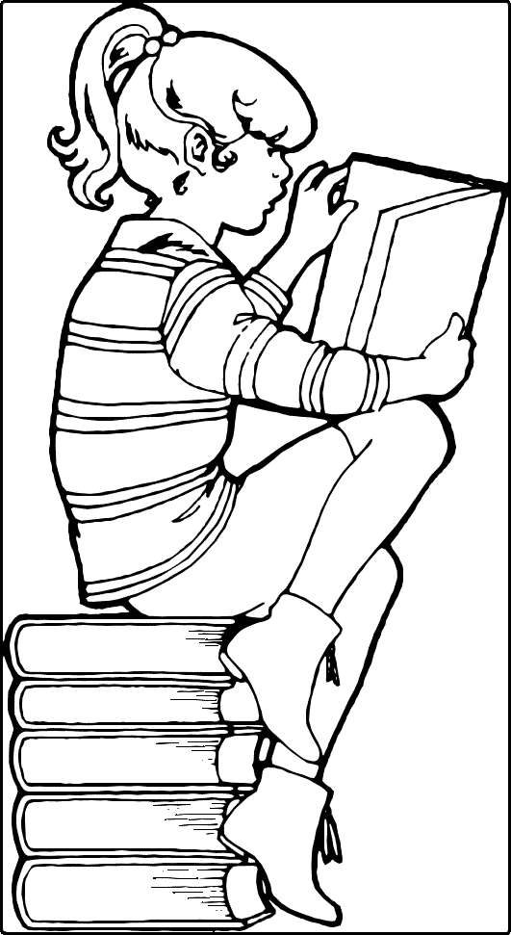
- Where do you study English?
  - I study English ____________________.
- When do you take a bath?
  - I take a bath _____________________.
- When do you watch TV?
  - I watch TV ______________________.

Step 2
Please ask your friends!

Name |  | Answer
 | Where do you eat lunch?
 | When do you read books?
 | Where do you study English?
 | When do you take a bath?
 | When do you watch TV?
Step 3

What did your friends say?

EXAMPLE: Miki reads books every night.

- ______________________________________________________________
- ______________________________________________________________
- ______________________________________________________________
- ______________________________________________________________
- ______________________________________________________________
- ______________________________________________________________
- ______________________________________________________________
- ______________________________________________________________
- ______________________________________________________________
- ______________________________________________________________

